Content Marketing plan
Website: https://www.smallbusinessaicoach.com/

Small business ai coach Brand identity:
AI guide
Bridging the gap between tech and business
Problem solver
Systems thinker

Use brand colors from the website, 90% light, 10% dark accents - like the burgundy. High contrast colors are preferred. Make sure the fonts are big enough to be clearly seen on a small mobile screen from different vision levels for the posts.

Content Goals - focus my marketing on my niche to drive:
Newsletter subs
Authority
Conversions sell courses through website, funnels, social cold dms
Meta Ads for Masterclasses and Challenges

Content Marketing style is The Five-Beat Story Structure
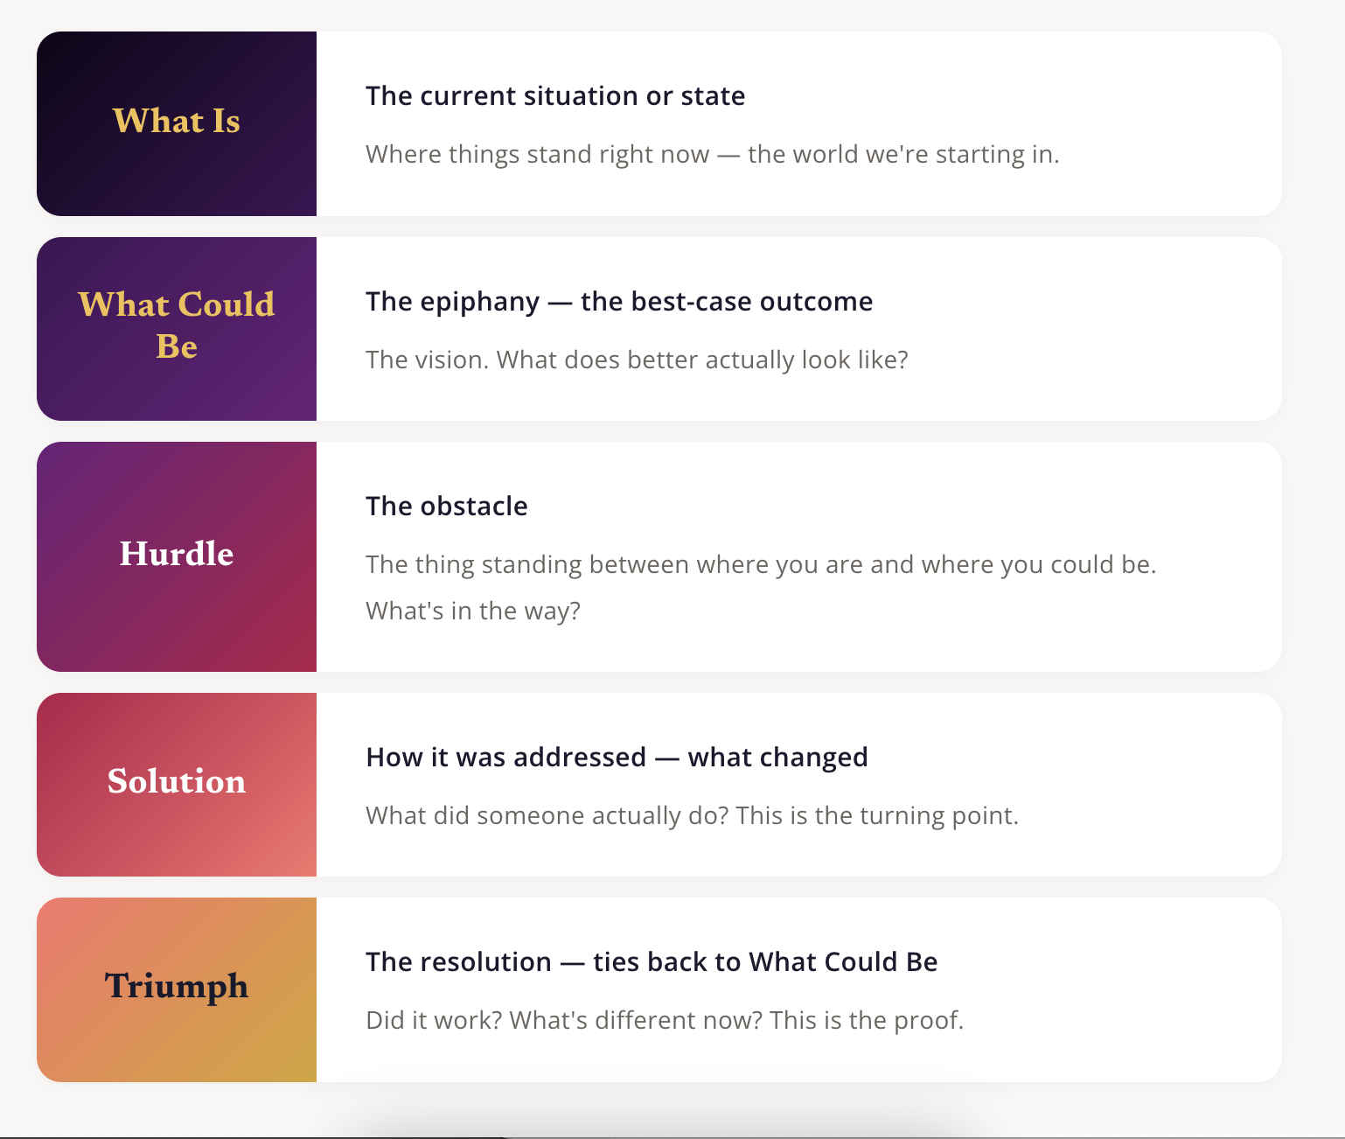

All content title & the 1st sentence of the description/caption of the post must be a Hook
All content must end with a CTA from the Active CTAs list

Active CTAs list
Subscribe to newsletter
Book a free diagnostic
Register for a webinar/masterclass/offer
Follow me, like me, share
Respond “word” and I will send you X lead magnet

Skills to use
/hormozi-style
/linkedin-content

Align all my Social profiles: Linkedin, Youtube, insta, tiktok, facebook - write profiles for each according to their specs and best practices for each platform for the goals. Inspire yourself from my bio and also my niche being small businesses + entrepreneurs, especially women.

Channels: respect rules/restrictions for each channel

YouTube - every week copy with Apify top creators in the AI small business coaching space
Make 2-3 long form and 5 short form (45sec) videos a week
Series: Easy Automations for all Business Functions with Claude - save 10/hrs a week
Operations, HR, Sales, Product + Project Management, etc every function but marketing
Series: Where to start with AI to automate your business admin: daily briefing, sales funnels, etc
Add video description with hook + CTA + hashtags for each post
Create 1-2 Lead magnets weekly based on viral YouTube content
Create transcripts for each youtube video, including which parts can become shorts to edit later.
Once approved, create a google slides for the video of the main points to follow during the recording. It has to have the same color/style scheme as the carousels. My name and website have to be at the bottom of each slide as of each carousel.

Insta/Tiktok/Facebook - every week copy with Apify top creators in the AI small business coaching space
Slides/Carousels - create it with the approved carousel template saved in Google Drive
I have to approve the content before you make the jpg and video.
My name and website have to be at the bottom of each carousel.

Add caption with hook + CTA + hashtags for each post. Pick the best CTA from the list
Use these Viral hooks: https://sabrinaramonov.notion.site/Viral-TikTok-Instagram-Hooks-113673112f9080838420d30c080f5f42

Popular Tiktok common templates are:
- Listicles (e.g. 7 youtube videos…)
- Negative (e.g. stop doing this…)
- Tutorials (e.g. how to build apps…)
- Breaking News (e.g. this is insane…)

Linkedin - copy with Apify top creators in the AI small business coaching space
/linkedin skill
Carousels - create it with the approved carousel template.
I need to approve the content before you create the pdf carousel.
Create Infographics posts from my YT videos - 1 infographic post a week
Add caption with hook + CTA + hashtags for each post in a text file for me to copy paste saved in Google Drive
Use these Viral hooks: https://sabrinaramonov.notion.site/Viral-TikTok-Instagram-Hooks-113673112f9080838420d30c080f5f42

Goals:
Authority
Drive to website
Newsletter subs

Each YouTube Video should become a Newsletter => Blog Post - link the video in the post

Monthly webinars/challenges - what funnels should i run monthly for my niche - use hormozi style skill

Content Hub: Create a CLI dashboard for all channels with Apify competitive viral post data for my niche (with profile examples already provided for each)

YouTube creators for data pull in Apify:
https://www.youtube.com/@sabrina_ramonov
https://www.youtube.com/@nateherk
https://www.youtube.com/@GregIsenberg
https://www.youtube.com/@duncanrogoff

Linkedin creators for data pull in Apify:
https://www.linkedin.com/in/monikamileva1/
https://www.linkedin.com/in/awa-k-penn/
https://www.linkedin.com/in/sabrinaramonov/
https://www.linkedin.com/in/nateherkelman/

Linkedin Posts to copy
https://www.linkedin.com/feed/update/urn:li:activity:7450302283063664640?updateEntityUrn=urn%3Ali%3Afs_updateV2%3A%28urn%3Ali%3Aactivity%3A7450302283063664640%2CFEED_DETAIL%2CEMPTY%2CDEFAULT%2Cfalse%29
https://www.linkedin.com/posts/pierre-cordelier-_ia-claude-powerpoint-activity-7450192478554517504-pg1_?utm_source=share&utm_medium=member_desktop&rcm=ACoAAAAsl-cBhDDcB837UBpGfRXKeZuqtB7Mgcs
https://www.linkedin.com/posts/anastasianak_after-ive-tried-claude-for-content-creation-activity-7449862468627054592-yerT?utm_source=share&utm_medium=member_desktop&rcm=ACoAAAAsl-cBhDDcB837UBpGfRXKeZuqtB7Mgcs
https://www.linkedin.com/feed/update/urn:li:activity:7450181176834658305?updateEntityUrn=urn%3Ali%3Afs_updateV2%3A%28urn%3Ali%3Aactivity%3A7450181176834658305%2CFEED_DETAIL%2CEMPTY%2CDEFAULT%2Cfalse%29
https://www.linkedin.com/feed/update/urn:li:activity:7449767874665304065?updateEntityUrn=urn%3Ali%3Afs_updateV2%3A%28urn%3Ali%3Aactivity%3A7449767874665304065%2CFEED_DETAIL%2CEMPTY%2CDEFAULT%2Cfalse%29
https://www.linkedin.com/feed/update/urn:li:activity:7448731695408631808?updateEntityUrn=urn%3Ali%3Afs_updateV2%3A%28urn%3Ali%3Aactivity%3A7448731695408631808%2CFEED_DETAIL%2CEMPTY%2CDEFAULT%2Cfalse%29
https://www.linkedin.com/feed/update/urn:li:activity:7448010038058737664?updateEntityUrn=urn%3Ali%3Afs_updateV2%3A%28urn%3Ali%3Aactivity%3A7448010038058737664%2CFEED_DETAIL%2CEMPTY%2CDEFAULT%2Cfalse%29
https://www.linkedin.com/feed/update/urn:li:activity:7445443703877468160?updateEntityUrn=urn%3Ali%3Afs_updateV2%3A%28urn%3Ali%3Aactivity%3A7445443703877468160%2CFEED_DETAIL%2CEMPTY%2CDEFAULT%2Cfalse%29
https://www.linkedin.com/feed/update/urn:li:activity:7447577065995980800?updateEntityUrn=urn%3Ali%3Afs_updateV2%3A%28urn%3Ali%3Aactivity%3A7447577065995980800%2CFEED_DETAIL%2CEMPTY%2CDEFAULT%2Cfalse%29
https://www.linkedin.com/feed/update/urn:li:activity:7449109081895784448?updateEntityUrn=urn%3Ali%3Afs_updateV2%3A%28urn%3Ali%3Aactivity%3A7449109081895784448%2CFEED_DETAIL%2CEMPTY%2CDEFAULT%2Cfalse%29
https://www.linkedin.com/feed/update/urn:li:activity:7442642240088231936?updateEntityUrn=urn%3Ali%3Afs_updateV2%3A%28urn%3Ali%3Aactivity%3A7442642240088231936%2CFEED_DETAIL%2CEMPTY%2CDEFAULT%2Cfalse%29

Tiktok creators for data pull in Apify - so you can figure out my niche
https://www.tiktok.com/@sabrina_ramonov
https://www.tiktok.com/@brooke_wrightmode
https://www.tiktok.com/@kristagreener
https://www.tiktok.com/@taki.gpt
https://www.tiktok.com/@iamkylebalmer

Instagram creators for data pull in Apify - so you can figure out my niche (use the same for Facebook)
https://www.instagram.com/zeeeljain/?g=5
https://www.instagram.com/claudeai/
https://www.instagram.com/adamstewartmarketing/
https://www.instagram.com/chase.h.ai/
https://www.instagram.com/wright_mode/
https://www.instagram.com/nathanhodgson.ai/
https://www.instagram.com/realrileybrown/
https://www.instagram.com/khris.sheer/
https://www.instagram.com/nateherkai/
https://www.instagram.com/sabrina_ramonov/

Competitive websites
https://uppitai.com/ - automation services - book a discovery call - it’s own page

https://consulting.jamout.ai/?_gl=1*n3af67*_gcl_au*MTc4NTcyMzYyNy4xNzc1NTAwMzM5*_ga*MjAxMTI5NDAzNy4xNzc1NTAwMzM4*_ga_CC76KWVX34*czE3NzY1MTY2NjMkbzMkZzEkdDE3NzY1MTY2OTYkajI3JGwwJGgw#investment - team training offer for 1 month - 4K/team of 5 or less

https://theaidepartment.com/

https://bossingai.theaidepartment.com/ - offer for 1month for entrepreneur women - can i call it a AI challenge? - 370$/person

Add an FAQ section for AEO for small business owners and entrepreneurs looking for AI education and automation services in the Work with me section of the website that answers all questions about my offers.

Weekly Content Process for Content Hub Dashboard update + Content Creation (Friday am)

Friday at 8am update the Content Hub dashboard with Apify data from the past week.

For each channel (YouTube, LinkedinIN, Tiktok, Insta, Facebook) add links to the top 10 posts for those creators I specified or the top posts for my niche with all key engagement metrics. Make the posts clickable so I can go to the original post. Add a checkbox next to each post so I can choose which posts to copy for that week. I can also provide the links of posts I like to copy. Once i have selected what to copy, then I click on a Create button for (1 create button for Insta/Tiktok posts, one for Linkedin Posts, one for YouTube content)

For insta, Facebook and tiktok: I will choose 7-10 posts to copy. Posts from insta, Facebook and tiktok will be repurposed as 1 for all. Respect platform rules and restrictions for format when creating the posts. The Carousel posts should have 2 formats - 1 just the post jpegs, 1 the jpegs turned into a video with 5 seconds per slide. I can also provide the links of posts I like to copy. To be saved on the google drive folder for that week under its channel.

For LinkedIn: I will choose 5 LinkedIn posts to copy to a linkedin carousel format. Respect platform rules and restrictions for format when creating the posts. To be saved on the google drive folder for that week under its channel. I can also provide the links of posts I like to copy.

For YouTube: I will choose 2-3 Youtube videos from the top 10 list and you will create transcripts of these videos and google slides presentation to guide the recording of each video from a google slide template that matches the carousel templates. Transcripts and google slides to be saved on the google drive folder for that week under its channel

For Blogs & Newsletters just have a long description text box for URLs and I will provide a URL and instructions on what to create for the blog.

Blog posts should have a small image for the card, propose a strategy to do that that doesn’t involve me

All content must be approved by me. Once I choose the posts to copy etc, you will work on the content and email me the summary of it all with links to google drive folder where I can read and edit the proposed content so you can finalize it in its final format. I will respond to the email when I am done with Done and you will use the drives content to put it in its ultimate format for social media networks.

Send me an email when it’s done.

Monthly activation & conversion strategy
On the 1st of each month

Podcasts
Once a month do a search for “AI for small business podcast” keyword and present the top 10 results for that month with the number of listeners. Put a checkmark on the podcast in case I want to create content from it.

AI Conferences
Once a month do a search for “AI conferences around me” keyword and present the top 10 new results coming up in the next 3-6 months.

Once a month create:
- 2 lead magnets/activation of DMs strategy
- 1 webinar/masterclass/event a month
- Podcast opportunities list to reach out to
- Public speaking opportunities list to apply for
- I need a DM strategy for lead magnets and automating that process, so once or twice a month we create a lead magnet we drop in the comments a word in a post, when they respond with the word they get the magnet, ideally we get their email at least for one of them if not both - use the hormozi style skill for lead magnet creation.

Present results in an email to abazdikian@gmail.com with recommended actions that you can follow up on.

